Rotator Cuff Injury

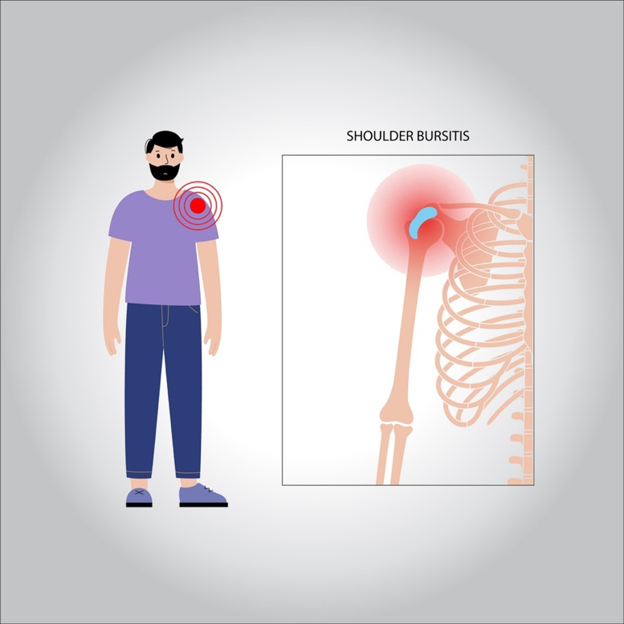

**The rotator cuff is a group of muscles and tendons that surround the shoulder joint, keeping the head of your upper arm bone firmly within the shallow socket of the shoulder. A rotator cuff injury can cause a dull ache in the shoulder, which often worsens when you try to sleep on the involved side.**

**Rotator cuff injuries occur most often in people who repeatedly perform overhead motions in their jobs or sports. Examples include painters, carpenters, and people who play baseball or tennis. The risk of rotator cuff injury also increases with age.**

**Many people recover from rotator cuff disease with physical therapy exercises that improve flexibility and strength of the muscles surrounding the shoulder joint.**

**Sometimes, rotator cuff tears may occur as a result of a single injury. In those circumstances, medical care should be provided as soon as possible. Extensive rotator cuff tears may require surgical repair, transfer of alternative tendons or joint replacement.**

**Symptoms**

* **The pain associated with a rotator cuff injury**
* **Be described as a dull ache deep in the shoulder**
* **Disturb sleep, particularly if you lie on the affected shoulder**
* **Make it difficult to comb your hair or reach behind your back**
* **Be accompanied by arm weakness**

**Treatment**

**Conservative treatments — such as rest, ice and physical therapy — sometimes are all that’s needed to recover from a rotator cuff injury. If your injury is severe and involves a complete tear of the muscle or tendon, you might need surgery.**

**Injections**

**If conservative treatments haven’t reduced your pain, your doctor might recommend a steroid injection into your shoulder joint, especially if the pain is interfering with your sleep, daily activities or exercise. While such shots are often temporarily helpful, they should be used judiciously, as they can contribute to the weakening of the tendon.**

**Physical Therapy**

**Physical therapy is usually one of the first treatments your doctor may suggest. Exercises tailored to the specific location of your rotator cuff injury can help restore flexibility and strength to your shoulder. Physical therapy is also an important part of the recovery process after rotator cuff surgery.**

**Surgery**

**Many different types of surgeries are available for rotator cuff injuries, including:**

* **Arthroscopic tendon repair. In this procedure, surgeons insert a tiny camera (arthroscope) and tools through small incisions to reattach the torn tendon to the bone.**
* **Open tendon repair. In some situations, an open tendon repair may be a better option. In these types of surgeries, your surgeon works through a larger incision to reattach the damaged tendon to the bone. Compared to arthroscopic procedures, open tendon repairs typically heal in the same length of time but recovery may be more uncomfortable.**
* **Tendon transfer. If the torn tendon is too damaged to be reattached to the arm bone, surgeons may decide to use a nearby tendon as a replacement.**
* **Shoulder replacement. Massive rotator cuff injuries may require shoulder replacement surgery. To improve the artificial joint’s stability, an innovative procedure (reverse shoulder arthroplasty) installs the ball part of the artificial joint onto the shoulder blade and the socket part onto the arm bone.**